**Java Test Automation App/Tool**

**Installation Guide**

By Software Quality Automation

**Contents**

1. Purpose 5

2. Java 5

2.1. OpenJDK 8 5

2.1.1. Copy Zip (or download) 5

2.1.2. Extract zip file 5

2.1.3. Rename folder 5

2.2. OpenJDK 11 6

2.2.1. Copy Zip (or download) 6

2.2.2. Extract zip file 6

2.2.3. Rename folder 6

2.3. JAVA_HOME setup 6

2.3.1. User environment property 6

3. Maven 8

3.1. Copy Zip 8

3.2. Extract zip file 8

3.3. Setup 9

3.4. User environment property 11

4. Eclipse 12

4.1. Copy Zip (or download) 12

4.2. Extract zip file 12

4.3. Rename folder 13

4.4. Setup 13

4.4.1. Update eclipse.ini 13

4.4.2. Certificate 14

4.4.3. Default JRE 14

4.4.4. Code templates 16

4.4.5. Logger 17

4.4.6. Selenium Template 18

4.5. Plugins 18

4.5.1. Installing plugins 19

4.6. Sample Java test automation project 20

4.6.1. Import GIT project 20

4.6.2. Setup project 20

4.6.3. Run sample test 20

5. Appium 20

**Revision History**

|  |  |  |
| --- | --- | --- |
| **Author** | **Description** | **Date** |
| Brian Keenan | Initial Version | 3/10/20 |
| Brian Keenan | Pati Christian feedback | 3/13/20 |
| Brian Keenan | Fixed mis-spelling and Final Version | 3/16/20 |
| Garrett Cosmiano | Updated eclipse setup | 02/03/21 |
| Garrett Cosmiano | Added mercurial install and link to doc guide | 02/16/21 |
| Garrett Cosmiano | Added SNOW request for temporary admin right | 03/16/21 |
| Garrett Cosmiano | Added configuring maven settings.xml | 03/30/21 |
| Garrett Cosmiano | Made the document to be generic (non-project specific) | 11/01/21 |
| Garrett Cosmiano | Remove reference to mercurial  Use user environment instead of system environment when setting Java/Maven home | 01/05/22 |
| Garrett Cosmiano | Added selenium template code | 02/10/22 |
| Garrett Cosmiano | Set JAVA_HOME with OpenJDK 11 instead of 8.  Set Eclipse default JRE to 8 as optional. | 06/17/22 |
| Garrett Cosmiano | Updated maven settings.xml to point to Nexus PROD | 06/27/22 |
| Garrett Cosmiano | Added IntelliJ | 07/25/22 |

# Purpose

This is the installation and setup guide for application used in test automation with Java programming language.

# Java

Java is the choice of a programing language for test automation and Excellus recommends RedHat OpenJDK.

Before proceeding, create a new **java** folder under your username: i.e., C:\Users\{username}\**java**

## OpenJDK 8

### Copy Zip (or download)

As of this writing (07/25/22), the latest version is 8u332-x64 (July 2022). Copy the zip file **java-1.8.0-openjdk-1.8.0.332-2.b09.redhat.windows.x86_64.zip** from \\w2rshr02\Data\IT\Soft_Qual_Mngt\AutomationServices\Eclipse into to your local folder or download a newer version in <https://developers.redhat.com/products/openjdk/download>.

### Extract zip file

Extract the local copy of the zip file into C:\Users\{username}\**java** folder (see below)

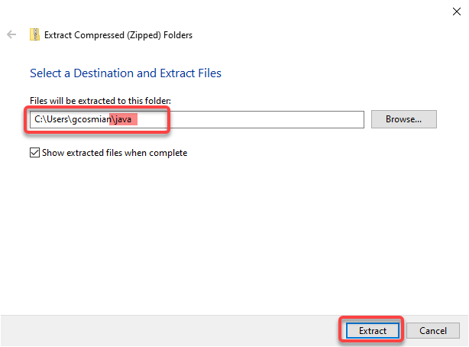

### Rename folder

Rename the folder C:\Users\{username}\java\**java-1.8.0-openjdk-1.8.0.302Address-1.b08.dev.redhat.windows.x86_64** into C:\Users\{username}\java\**openjdk_1.8_redhat**

## OpenJDK 11

### Copy Zip (or download)

As of this writing (7/25/22), the latest version is 11.0.15-x64 (July 2022). Copy the zip file **java-11-openjdk-11.0.15.9-4.windows.redhat.x86_64.zip** from \\w2rshr02\Data\IT\Soft_Qual_Mngt\AutomationServices\Eclipse into to your local folder or download a newer version in <https://developers.redhat.com/products/openjdk/download>.

### Extract zip file

Extract the local copy of the zip file into C:\Users\{username}\**java** folder (see below)



### Rename folder

Rename the folder C:\Users\{username}\java\**java-11-openjdk-11.0.12.7-1.windows.redhat.x86_64** into C:\Users\{username}\java\**openjdk_11_redhat**

## JAVA_HOME setup

Ideally, JAVA_HOME should be setup with OpenJDK 11 but it can be setup with JDK 8, depending on the need.

### User environment property

1. Search **Edit** **environment** and select ‘Edit environment variables for your account’

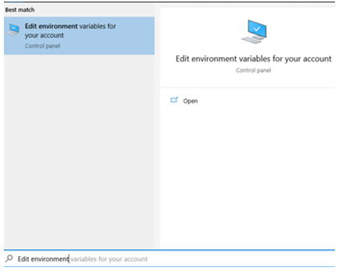

1. Click **New** (or **Edit** if JAVA_HOME already exists) button under **User variables for {username}** and fill the values as follows (use **Browse Directory** to navigate to the JDK folder) then click **OK** button

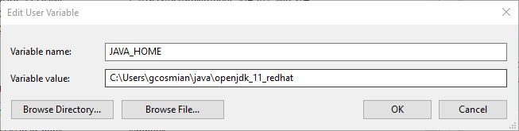

1. Under **User variables for {username}**, select **Path** variable and click **Edit** button

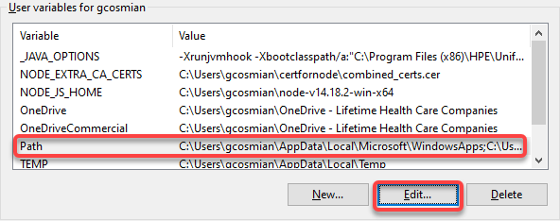

1. In the popup **Edit environment variable**, click **New** (or **Edit** if %JAVA_HOME%\bin already exists) button then type the ***%JAVA_HOME%\bin***and click **OK** button.

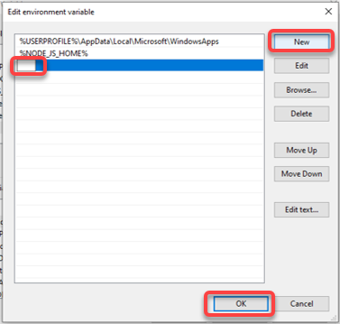

1. Click **Apply** and then **OK** buttons
2. Open Windows command line and run the command ***java -version*** and this will display the java version

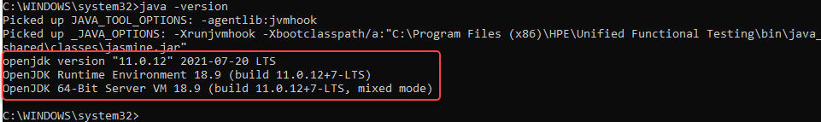

# Maven

Maven is used for managing builds and library dependency, see [Maven](https://maven.apache.org/) for more details.

Before proceeding, create a new maven folder under your username: i.e., C:\Users\{username}\**maven**

## Copy Zip

The maven version will use is 3.6.3. Copy the zip file **apache-maven-3.6.3-bin.zip** from \\w2rshr02\Data\IT\Soft_Qual_Mngt\AutomationServices\Eclipse into to your local folder.

## Extract zip file

Extract the local copy of the zip file into C:\Users\{username}\**maven** folder (see below)

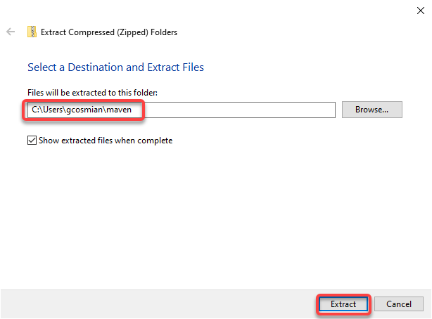

## Setup

1. Create a new **.m2** folder under your username: i.e., C:\Users\{username}\**.m2**
   1. Open command line
   2. Change directory to maven directory
   3. Run command line **mkdir .m2**

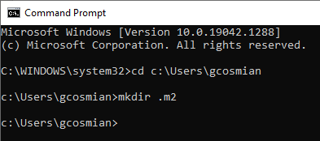S

1. Create a new file settings.xml in the new folder C:\Users\{username}\**.m2** with the content below (double click the xml below to select the content)



## User environment property

1. Search **Edit** **environment** and select ‘Edit environment variables for your account’



1. Click **New** button under **User variables for {username}** and fill the values as follows then click **OK** button

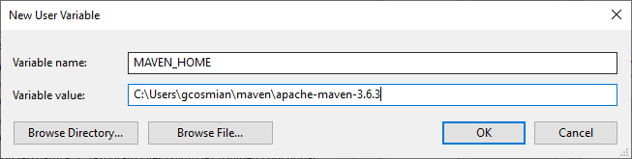

1. Under **System Variables**, select **Path** system variable and click **Edit** button



1. In the popup **Edit environment variable**, click **New** (or **Edit** if MAVEN_HOME already exists) button then type the ***%MAVEN_HOME%\bin***and click **OK** button.



1. Click **Apply** and then **OK** buttons
2. Open Windows command line and run the command ***mvn -version*** and this will display the maven version.

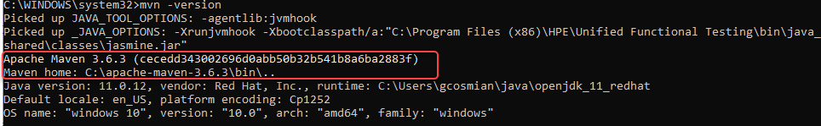

# Eclipse

The integrated development environment (IDE) that is recommended is [Eclipse](https://www.eclipse.org/downloads/packages/release/kepler/sr1/eclipse-ide-java-developers).

Before proceeding, create a new **eclipse** folder under your username: i.e., C:\Users\{username}\**eclipse**

## Copy Zip (or download)

As of this writing, the latest version is 2022-06-R. Copy the zip file **eclipse-java-2022-06-R-win32-x86_64.zip** from \\w2rshr02\Data\IT\Soft_Qual_Mngt\AutomationServices\Eclipse into to your local folder or download a newer version in <https://www.eclipse.org/downloads/packages/>

## Extract zip file

Extract the local copy of the zip file into C:\Users\{username}\**eclipse** folder (see below)

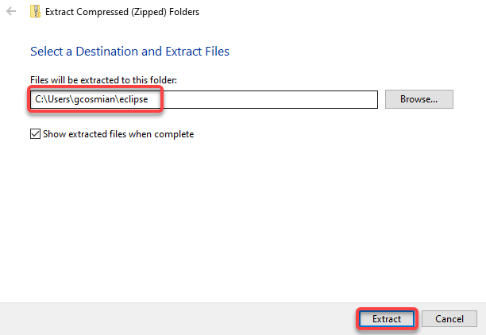

## Rename folder

Rename the folder C:\Users\{username}\eclipse\**eclipse** into C:\Users\{username}\eclipse\**eclipse_2021-06**

## Setup

### Update eclipse.ini

1. Open and edit the file C:\Users\{username}\eclipse\eclipse_2021-06\**eclipse.ini**
2. Update the highlighted line below to point to OpenJDK 11 bin folder; i.e., ***C:/Users/{username}/java/openjdk_11_redhat/bin***

-startup

plugins/org.eclipse.equinox.launcher_1.6.0.v20200915-1508.jar

--launcher.library

plugins/org.eclipse.equinox.launcher.win32.win32.x86_64_1.2.0.v20200915-1442

-product

org.eclipse.epp.package.java.product

-showsplash

org.eclipse.epp.package.common

--launcher.defaultAction

openFile

--launcher.defaultAction

openFile

--launcher.appendVmargs

-vm

plugins/org.eclipse.justj.openjdk.hotspot.jre.full.win32.x86_64_16.0.1.v20210528-1205/jre/bin

-vmargs

-Dosgi.requiredJavaVersion=11

-Dosgi.instance.area.default=@user.home/eclipse-workspace

-Dsun.java.command=Eclipse

-XX:+UseG1GC

-XX:+UseStringDeduplication

--add-modules=ALL-SYSTEM

-Dosgi.requiredJavaVersion=11

-Dosgi.dataAreaRequiresExplicitInit=true

-Xms256m

-Xmx2048m

--add-modules=ALL-SYSTEM

### Certificate

1. Download and copy the security certificate ​ icon [jssecacerts](https://lifethc.sharepoint.com/:u:/r/sites/SQAArchitectureAndAutomationTeam_EIT_GRP/Shared%20Documents/General/Technical%20Testing%20References/Java/jssecacerts?csf=1&web=1&e=hXnldT) into the OpenJDK folder ***C:/Users/{username}/java/openjdk_11_redhat/lib/security***

### Default JRE

By default, the default JRE for projects will be set to OpenJDK 11 but that can be change if needed. Below is the instruction to set JRE to use OpenJDK 8

1. Open Eclipse (double C:\Users\{username}\eclipse\eclipse_2021-06\eclipse.exe)
2. Select eclipse menu **Window** > **Preference**

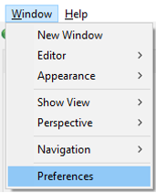

1. Select/expand **Java** > **Installed JREs** then click **Add** button

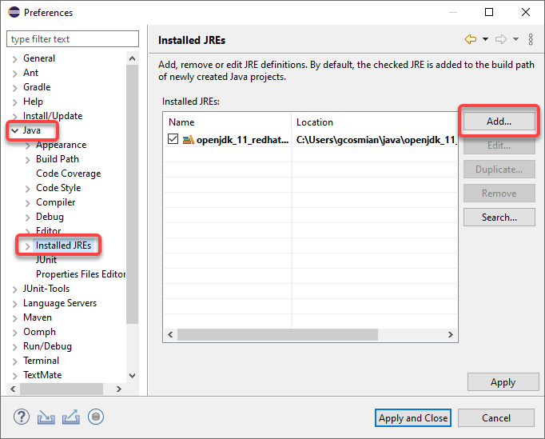

1. Select **Standard VM** and click **Next >** button

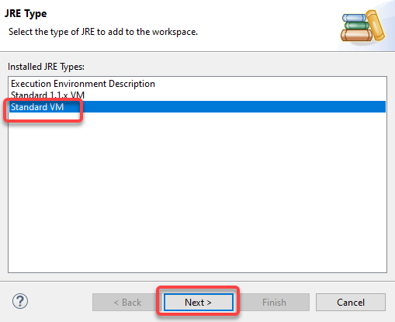

1. Click **Directory** button and navigate to C:\Users\{username}\java\**openjdk_1.8_redhat** then click **Select Folder** button. This will populate the fields (see below) and click **Finish** button.

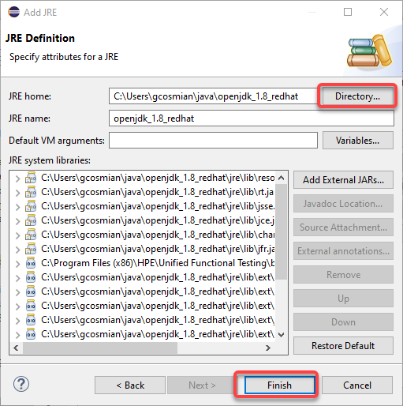

1. Enable **openjdk_1.8_redhat** as default JRE and click **Apply and Close** button.

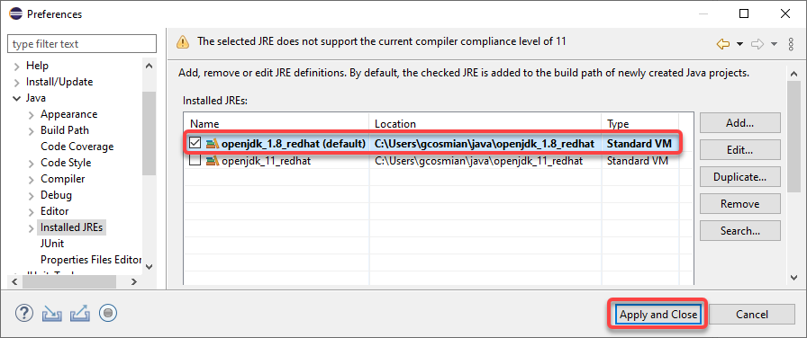

### Code templates

1. Open Eclipse (double C:\Users\{username}\eclipse\eclipse_2021-06\eclipse.exe)
2. Go to Eclipse menu **Window** >> **Preferences**
3. Expand **Code** and select **New Java files** then click **Edit** button

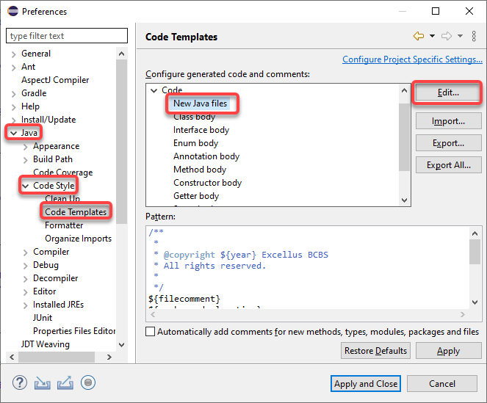

1. Delete all content in the Pattern and replace it with the content below but ***make sure to update the FirstName and LastName with your own name.***
2. Click **OK** button then **Apply and Close** button

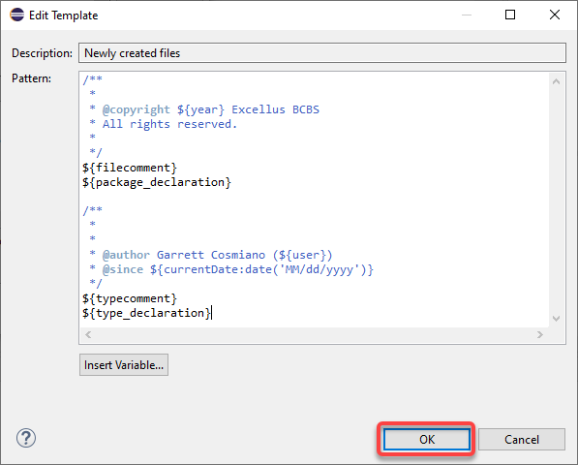

### Logger

1. Open Eclipse (double C:\Users\{username}\eclipse\eclipse_2021-06\eclipse.exe)
2. From the Preference dialog box, go to **Java** > **Editor** > **Templates**
3. Click **New…** button to add a new shortcut

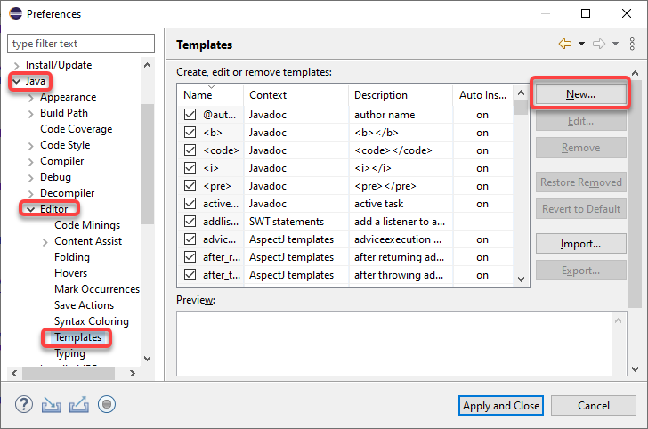

1. Fill in the **New Template** dialog box as follows

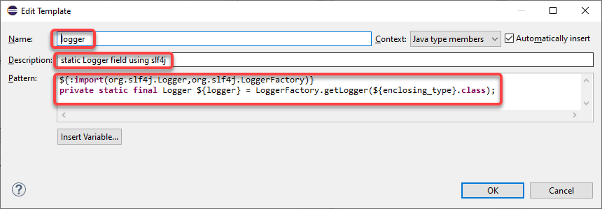

${:**import**(org.slf4j.Logger, org.slf4j.LoggerFactory)}

**private** **static** **final** Logger logger = LoggerFactory.getLogger(${enclosing_type}.**class**);

1. Click **OK** button then **Apply and Close** button

### Selenium Template

SpringImport the Selenium code template – [​xml icon selenium_templates.xml](https://lifethc.sharepoint.com/:u:/r/sites/SQAArchitectureAndAutomationTeam_EIT_GRP/Shared%20Documents/General/Technical%20Testing%20References/Java/Java_Code_Eclipse_Templates/selenium_templates.xml?csf=1&web=1&e=kjlJYS) (see section **Selenium Template** of the [Selenium Best practices](https://lifethc.sharepoint.com/:w:/r/sites/SQAArchitectureAndAutomationTeam_EIT_GRP/Shared%20Documents/General/Technical%20Testing%20References/Java/Selenium%20and%20Java%20Programming%20Best%20Practices.docx?d=w69955b107ddd4f2694f36578860c3f0c&csf=1&web=1&e=K5hxnS))

## Plugins

**NOTE: There has been issue installing these plugins and if that happens then skip it for now.**

Install these plugins as needed

1. [JUnit-Tools](http://junit-tools.org/) – **(required)** provides shortcuts to create/run JUnit test
2. [Spring Tools 4 (aka Spring Tools Suite 4)](https://spring.io/tools) – (**optional)** helps create/manage spring beans configuration
3. [Spring Tools 3 Add-On for Spring Tools 4](https://marketplace.eclipse.org/content/spring-tools-3-add-spring-tools-4) – **(optional)** add-on pack from previous version
4. [Groovy Development Tools](http://groovy-lang.org/) – **(optional)** supports groovy programming language but we currently use it as Jenkins’ pipeline editor. *Make sure select* ***Groovy Compiler 3.0*** *when prompted.*

Follow the steps below to install these plugins

### Installing plugins

1. Open Eclipse (double C:\Users\{username}\eclipse\eclipse_2021-06\eclipse.exe)
2. Select eclipse menu **Help** > **Eclipse Marketplace**

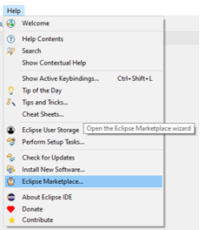

1. Search for the plugin (see sample below) and click **Install** button

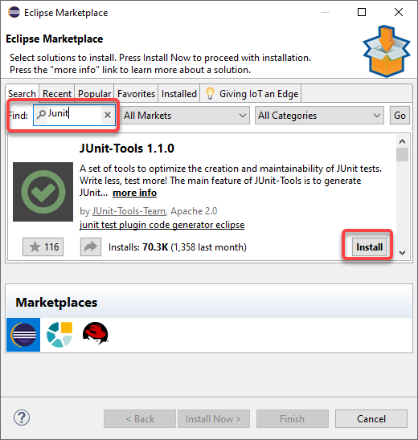

1. Click **Confirm** button when prompted
2. Select ***I accept the terms of the license agreements*** when prompted.
3. Click **Finish** button
4. Select **Install anyway** button when prompted

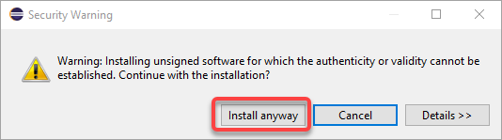

1. Click **Restart Now** button (to restart eclipse) when prompted.

## Sample Java test automation project

***Coming soon***

### Import GIT project

### Setup project

### Run sample test

# IntelliJ

IntelliJ is another IDE that can be used for test automation. However, use this in your discretion as not a lot have experience on this IDE.

## Copy Zip (or download)

As of this writing, the latest version is 2022.1.4. Copy the zip file **ideaIC-2022.1.4.win.zip** from \\w2rshr02\Data\IT\Soft_Qual_Mngt\AutomationServices\Eclipse into to your local folder or download a newer version in <https://www.jetbrains.com/idea/download/#section=windows> (Community Edition)

## Extract zip file

Extract the local copy of the zip file into C:\Users\{username}\**IntelliJ** folder (see below)

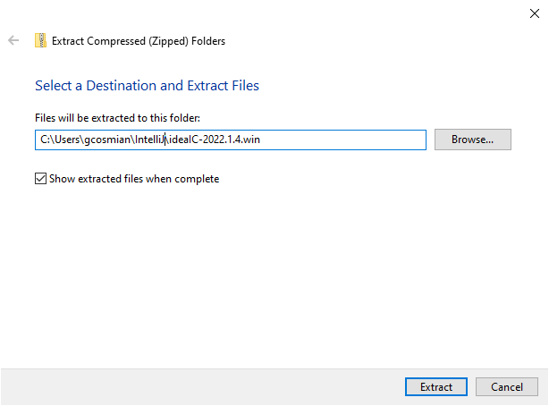

## Rename folder

Rename the folder C:\Users\{username}\IntelliJ\**ideaIC-2022.1.4.win** into C:\Users\{username}\IntelliJ\IntelliJ_2022.1.4

## Setup

### Code templates

1. Download the template [settings.zip](https://lifethc.sharepoint.com/:u:/r/sites/SQAArchitectureAndAutomationTeam_EIT_GRP/Shared%20Documents/General/Technical%20Testing%20References/Java/Java_code_IntelliJ_Templates/settings.zip?csf=1&web=1&e=YBtg6O) from Sharepoint.
2. Open IntelliJ (double C:\Users\{username}\IntelliJ\IntelliJ_2022-1.4\bin\idea64.exe)
3. Go to IntelliJ menu **File** >> **Manage IDE Settings >> Import Settings**

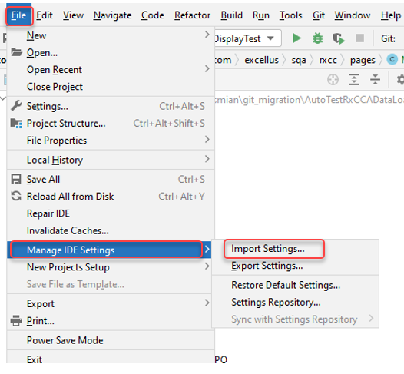

1. Navigate to where settings.zip was downloaded (from step 1) and select the file.

# Appium

[Appium](https://appium.io/) is used primary for test automation of mobile web application and as of a year or so ago it introduced capability to test automate Windows desktop applications.

***Coming soon***